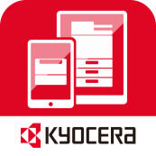
Mypanel
Software
Information

KYOCERA MyPanel 1.0
Software Information

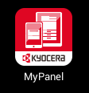 | 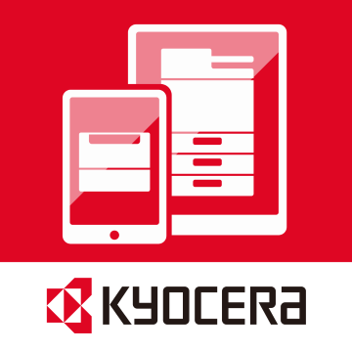
iOS and Android | Windows Phone

Version 2015-04-20
April 20th, 2015
KDE EMC / SNO

Contents

I. Overview 3
II. Features 3
1. Copy 3
2. Send 4
3. Custom Box 5
4. Add Workflow 8
5. Evernote 8
6. Dropbox 9
7. OneDrive 10
8. Create a QR Code 10
9. Select Device 11
10. Device Information 12
11. System Menu 13
12. Customize your home screen 15
13. Feature Management 15
III. Application Requirements 16
1. Supported File Types 16
2. Supported Languages 17
3. Supported Operating Systems 17
4. Supported Device Models 17

Overview

KYOCERA MyPanel is an app that lets you connect your mobile devices wirelessly to compatible KYOCERA printing devices on your local Wi-Fi network. When connected, users can perform the following operations easily.

- Copy a document
- Scan and send a document
- Print files in a custom box
- Save settings as a workflow
- Run workflow to any devices
- Preview and print Evernote notes and attachments
- Preview and print Dropbox files
- Preview and print OneDrive files
- Generate and print QR code
- Display device information
- Set authentication and manage features
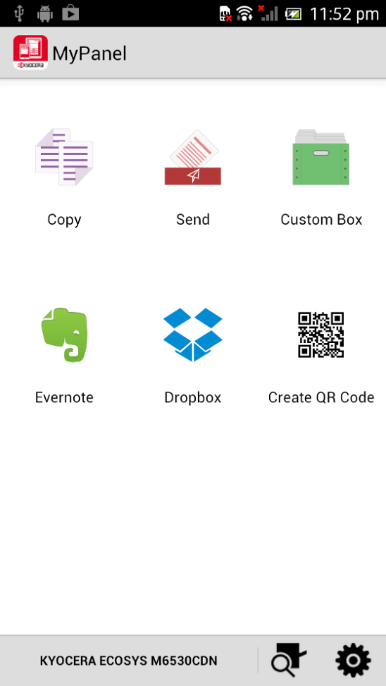 | 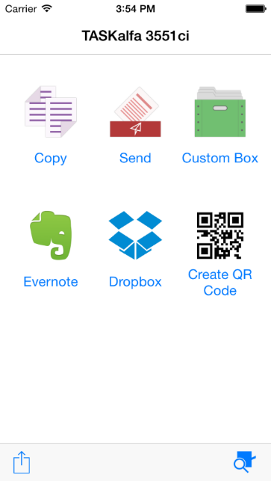 | 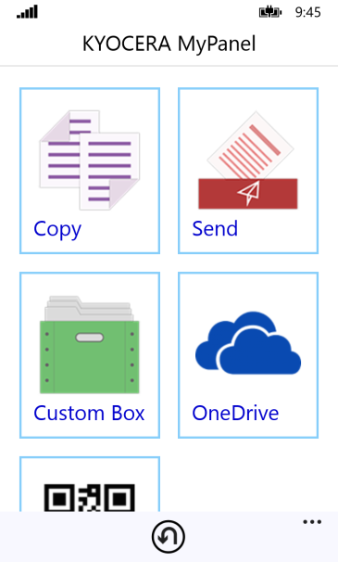
Android | iOS | Windows Phone

In addition, MyPanel can save commonly used settings as workflows. These workflows can be used and operated on all devices – whether A3 device, A4 device or printer as one identical operation.

KYOCERA MyPanel is available for download from iTunes (for iOS devices), Google Play (for Android devices), and Windows Phone Store (for Windows Phone devices). The app is free of charge, and there is no activation process for the devices.

Features

Copy

Use MyPanel to configure and run a copy job with documents placed in the document feeder or on the platen of the device.

・Copy Settings

The user can select various copy options. (Combine, Zoom, Original Orientation, Colour Selection, EcoPrint, Paper Selection, Density, Duplex, Original Size, Original Image, Continuous Scan, Number of Copies). These can be saved as a workflow for later reuse.

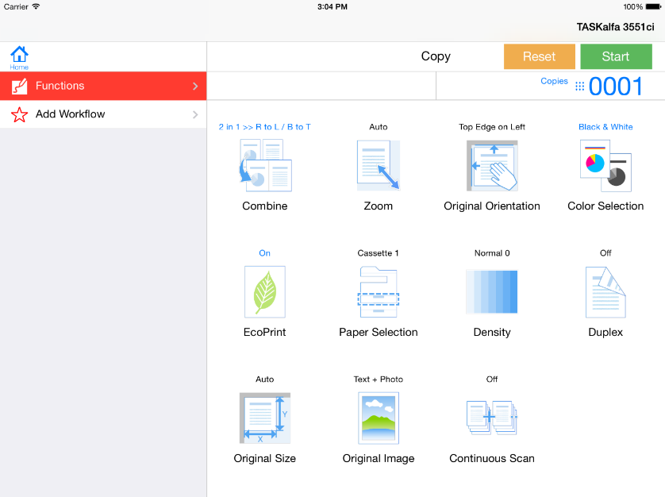
Copy settings

Send

Scan your documents and send them to an e-mail address or other designated location. Scanned images can be sent by e-mail, to Dropbox (iOS and Android), to Evernote (iOS and Android), to OneDrive (Windows Phone), and to a shared folder. E-mail addresses can be selected from the device address book or from the address book on the mobile.

・Destinations

There are multiple options for sending and storing your scanned documents.
 | Enter an e-mail address.
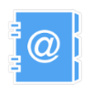 | Select an e-mail address from the device address book.
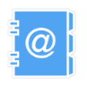 | Select an e-mail address from your mobile contacts.
 | Specify a shared folder.
 | Select a notebook from your Evernote account (iOS and Android).
 | Select a folder from your Dropbox account (iOS and Android).
 | Select a folder from your OneDrive account (Windows Phone).

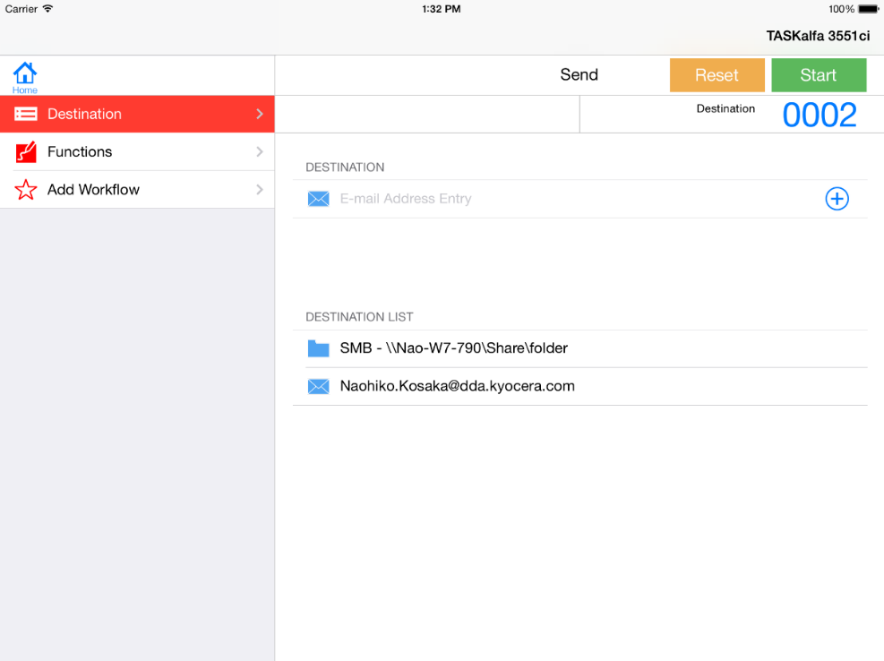
Destination screen

・Send Settings
The user can select send options (Scan Resolution, Colour Selection, Original Orientation, File Format, Zoom, Sending Size, Density, Original Size, Original Image, Continuous Scan). These settings can be saved as a workflow for later reuse.

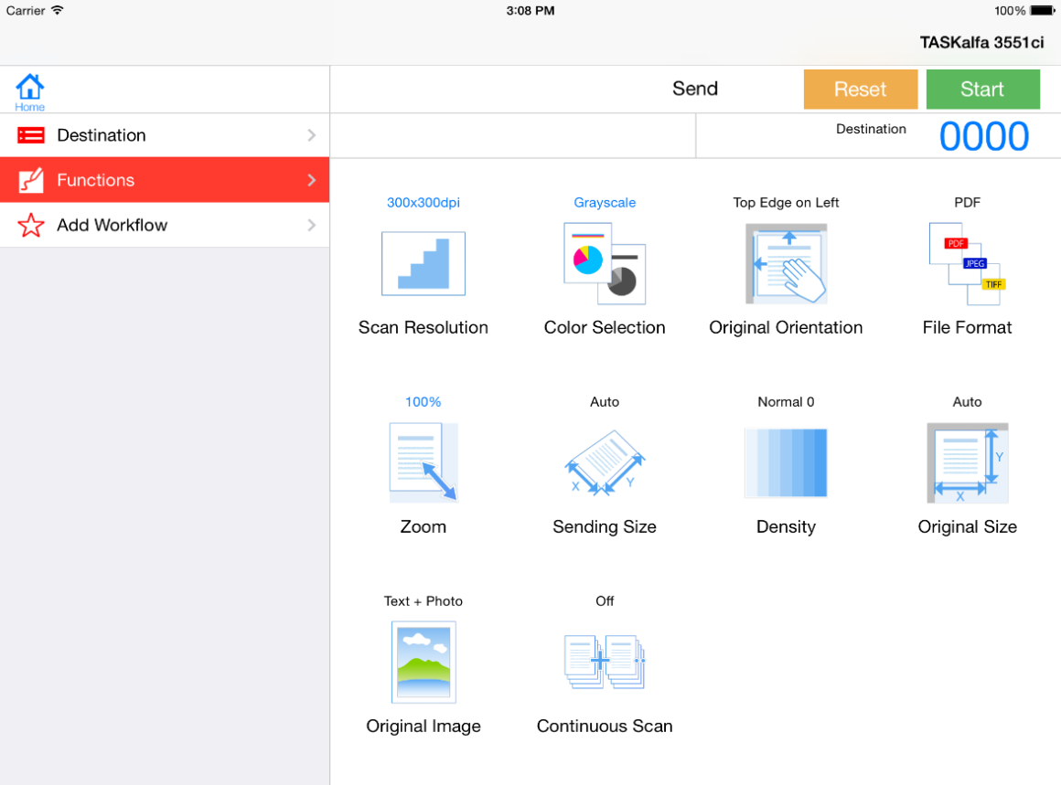
Send settings

Custom Box

View the contents and print documents stored in existing custom boxes on the device. You can also create a new custom box to store your documents.
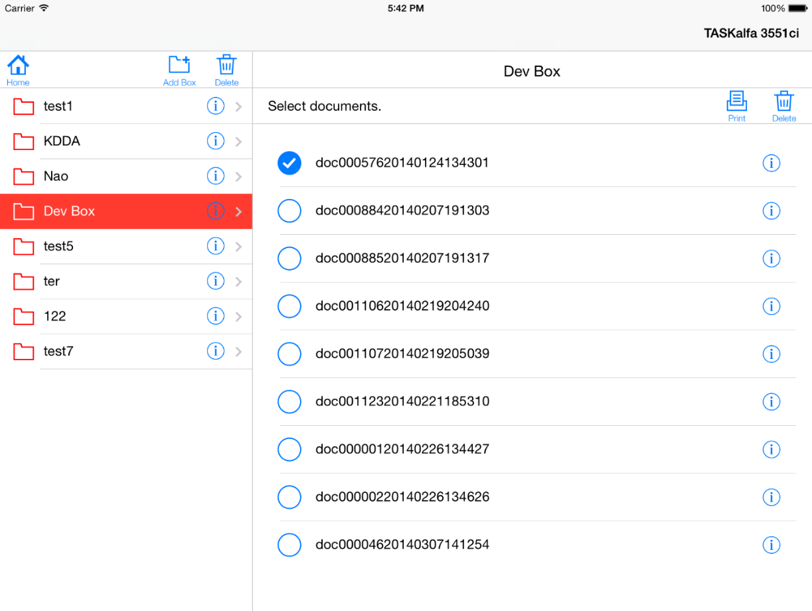
Custom Box
・Box Print

Print documents from a custom box. You can also set many printing options from this feature, and save them to a workflow for later reuse.

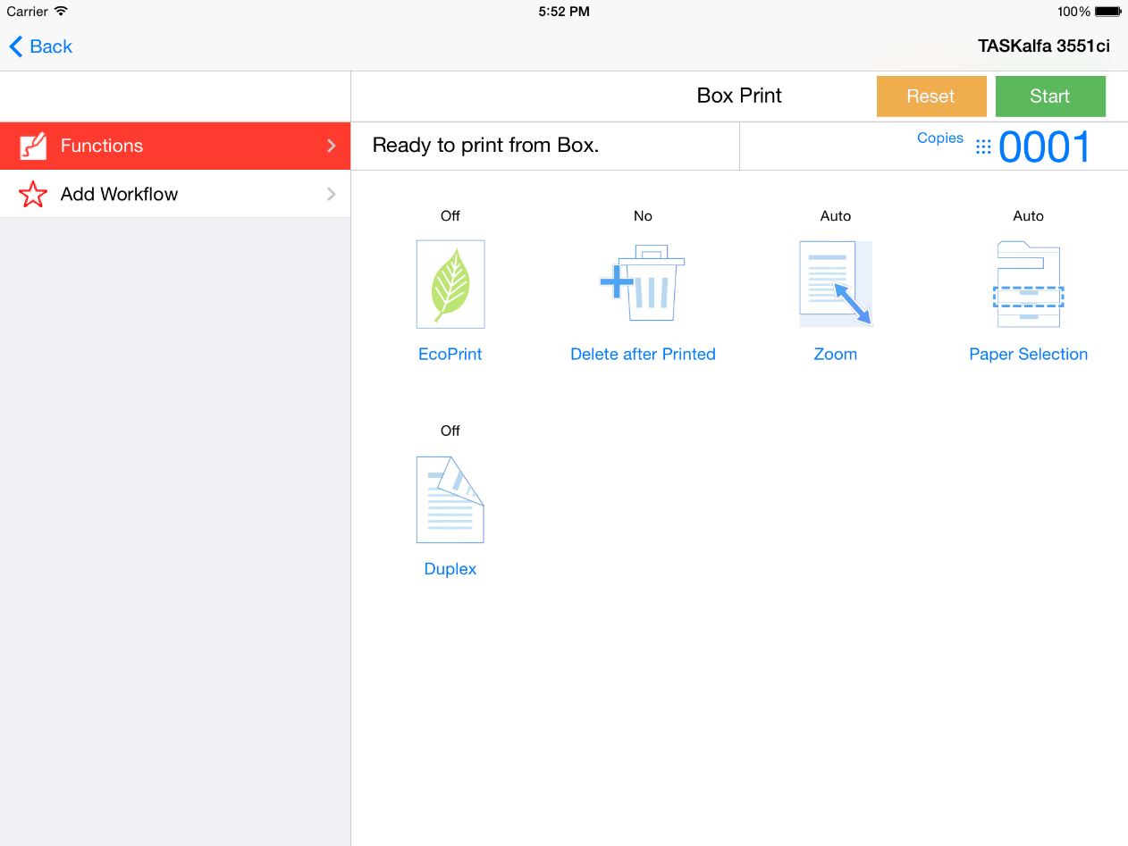
Box Print

・Box Information

View information about the custom box such as box name, number, owner name, and total used space.
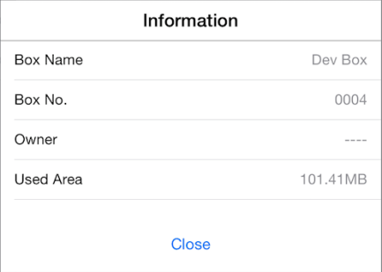
Box Information
・Document Information

View information about each custom box document such as file name, data size, resolution, and colour.

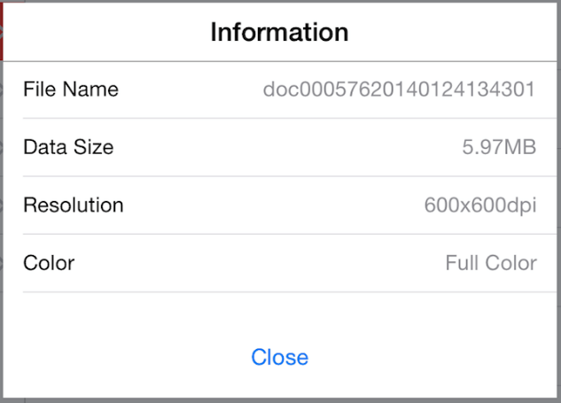
Document Information
・Add New Box

Create a new custom box on the device.

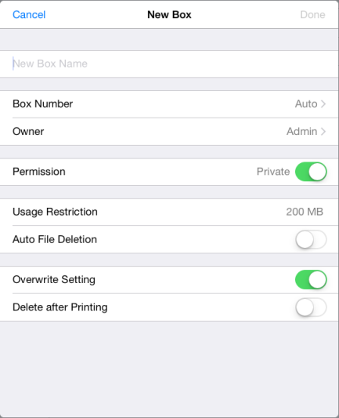
Creating a new custom box

Add Workflow

Create a workflow for one-touch access to apply settings or run a job. You can select that workflow to run the same type of job again without having to reselect all the settings. Workflows are saved as separate icons on the home screen.
The Add Workflow feature is available from the Copy, Send or Box Print screens.

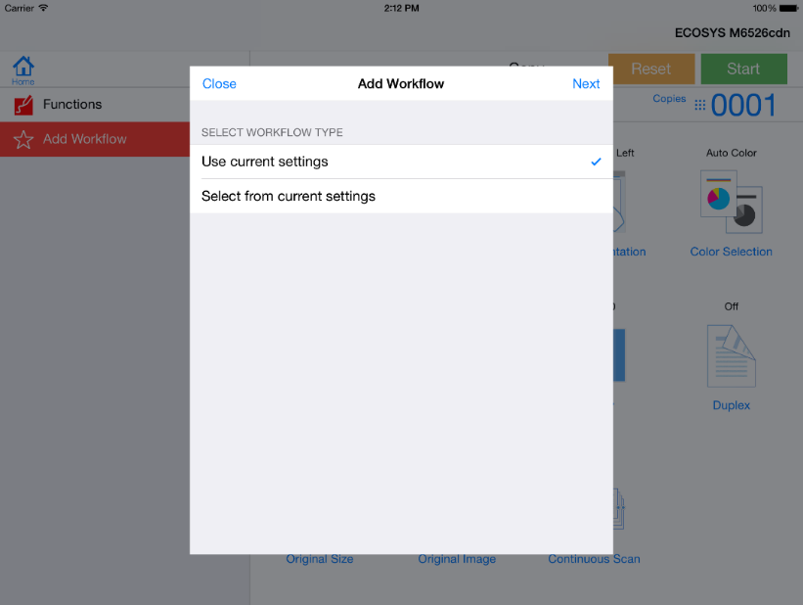
Selecting a workflow type
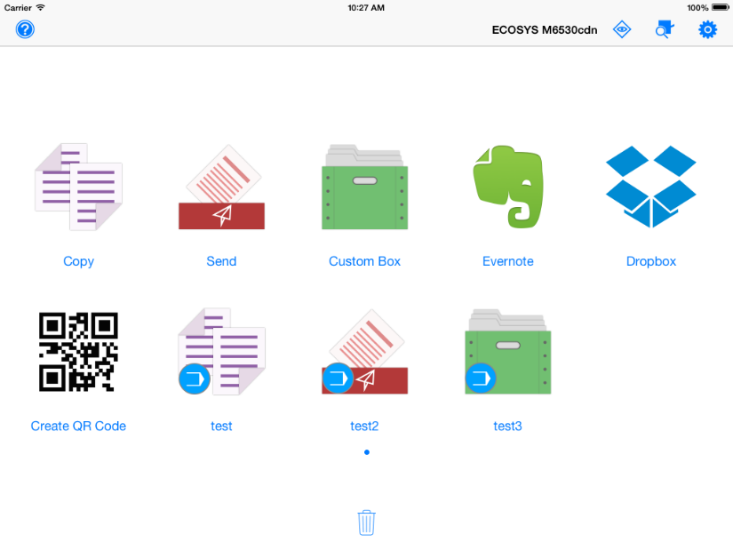
New workflow icon appears on the home screen

Evernote

Preview and print notes and attachments from your Evernote account. You do not need to install the Evernote app on your mobile to use this feature. To register for a new Evernote account, go to the Evernote website or register through their app.
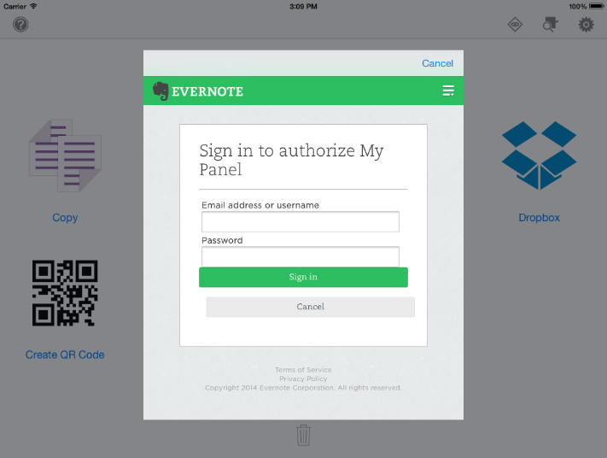
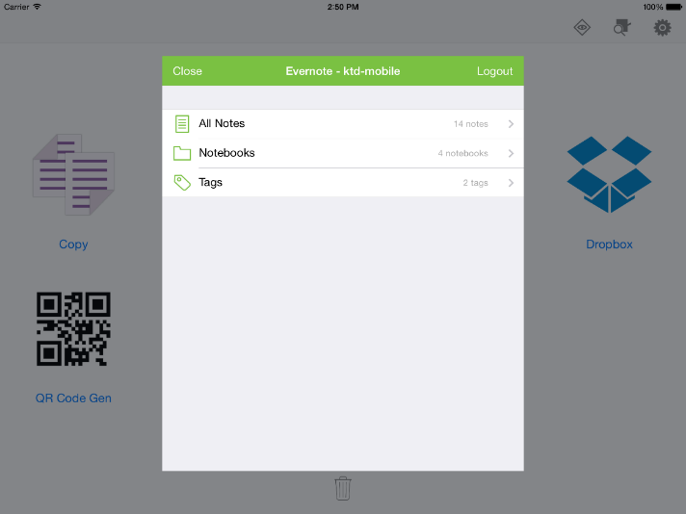

Sign in to Evernote account Select a note in Evernote
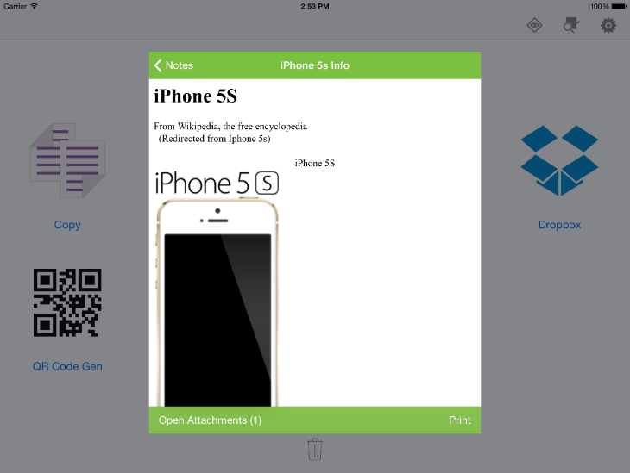

Preview and Print a note in Evernote

Dropbox

Preview and print files from your Dropbox account. You do not need to install the Dropbox app on your mobile to use this feature. To register for a new Dropbox account, go to the Dropbox website or register through their app. This feature is available for iOS and Android devices.

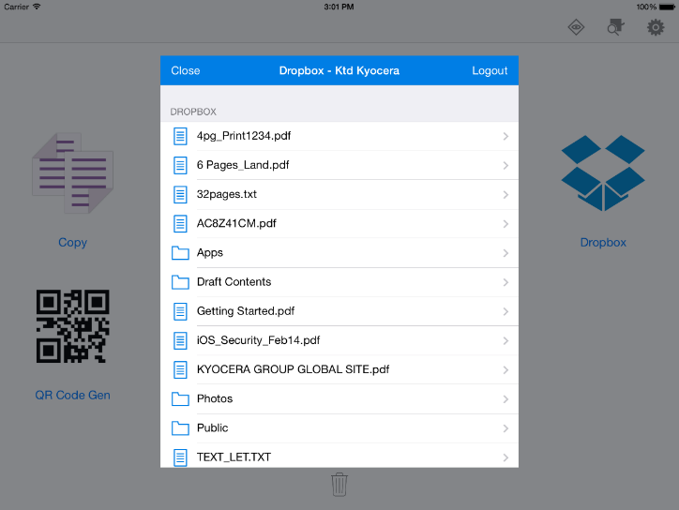
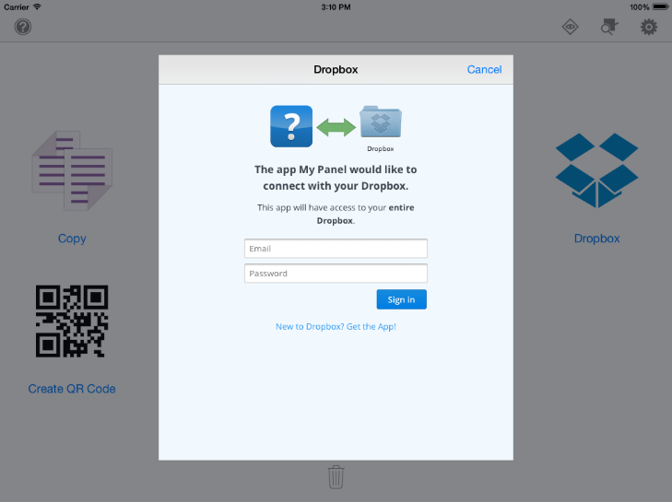
Signing in to a Dropbox account Select a note in Dropbox account
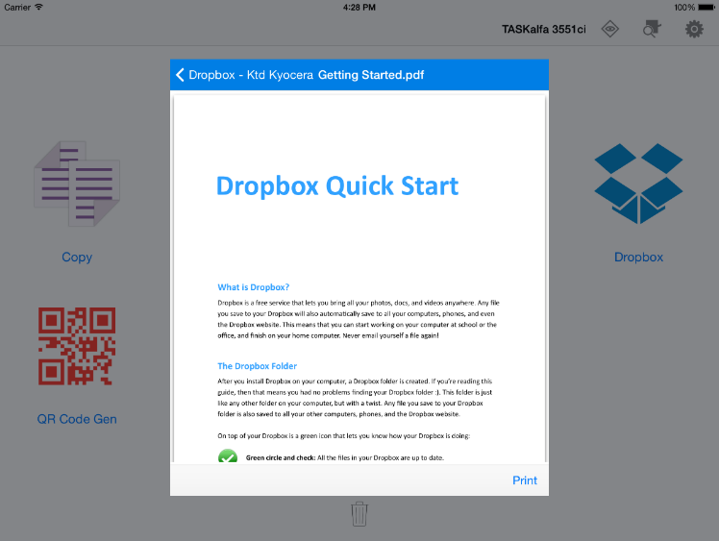
Previewing a document in Dropbox

OneDrive

Preview and print notes and attachments from your OneDrive account. This feature is available for Windows Phone devices. You do not need to install the OneDrive app on your mobile to use this feature. To register for a new OneDrive account, go to the OneDrive website or register through their app.

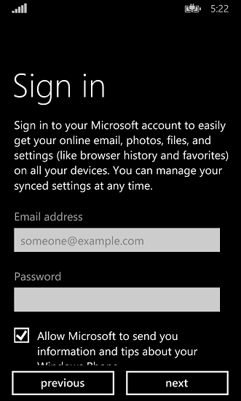 | 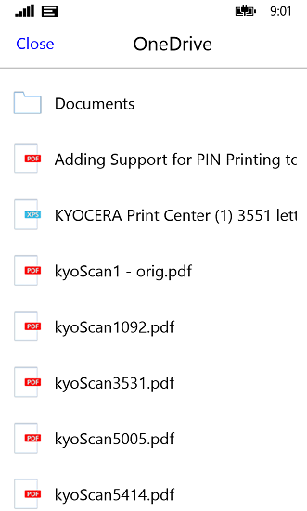 | 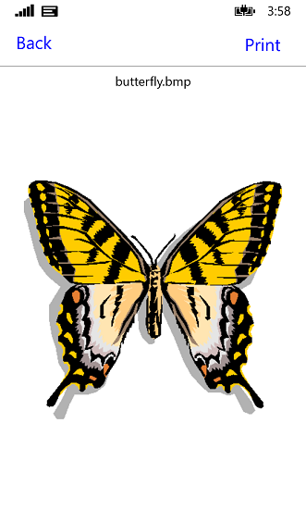
Signing in to a OneDrive account | OneDrive files | Previewing a file

Create a QR Code

Create a QR code that identifies a device by model name and IP address. Only IPv4 addresses are supported in this release. Print the QR code and affix it to the printing device. The QR code can then be scanned to add the device to the device list.
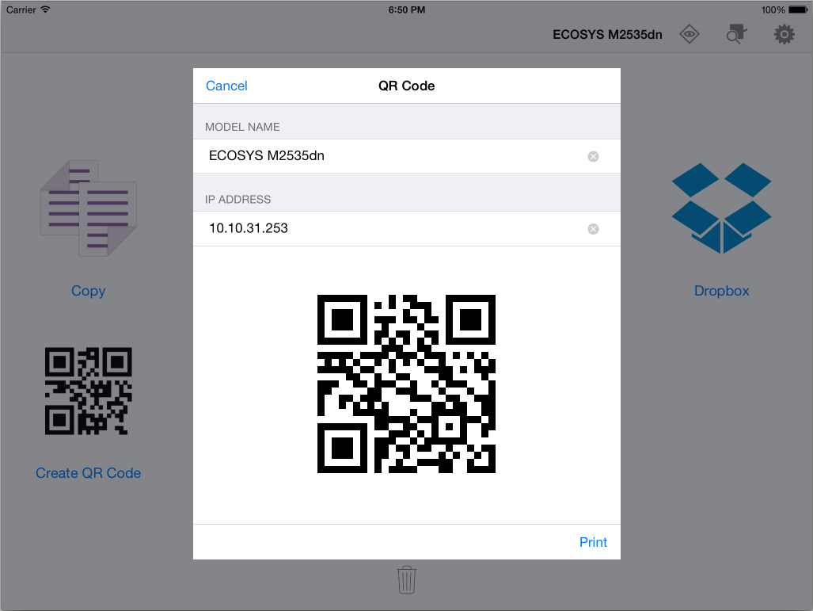
Create QR Code feature

Select Device

Find and connect to devices on your network. You can specify the device IP addresses, run a device discovery, or use the QR code scan feature. You can also select from a list of recently used devices, or from a custom Favourites list.

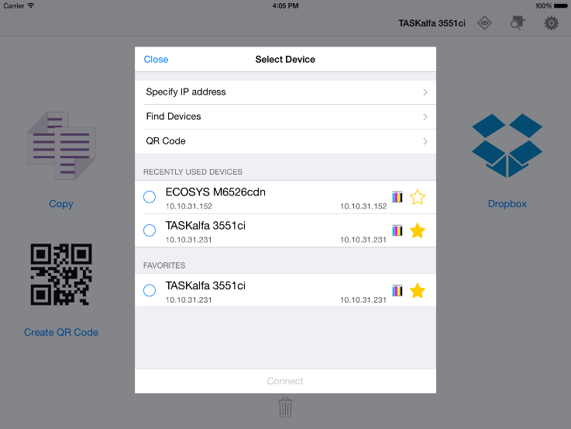
Select a device

・Specify IP address

Enter the IP address of the device you want to add.

・Find Devices

Run a device discovery to find connected devices.

・Scan QR Code

The QR Code feature launches the mobile’s camera and can detect QR codes for devices. After a QR code is confirmed, you can connect to the device and use it with the app’s other features.

・Recently Used Devices and Favorite Devices

The Select Device screen displays the last 10 devices used with the app. Tap on any one of the devices to connect to it. Tap the star icon next to a device to add it to your Favorites list. You can also remove a device from either list.

Device Information

View detailed device status and information for each device.

・Device Status

Displays paper size, media type, capacity, and status of installed paper feeders and the MP tray. All toner levels and the status of the waste toner box are also displayed.
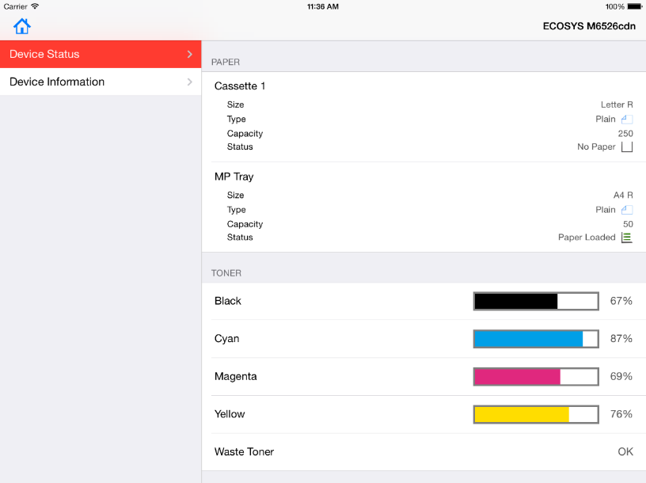
Device status

・Device Information

Displays model name, host name, IP address, identification information, total memory, scanning and printing capabilities, and installed device options such as paper feeders and finishers.

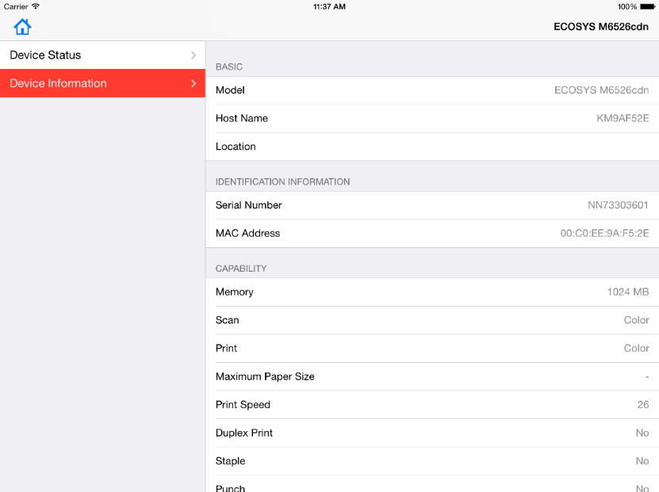
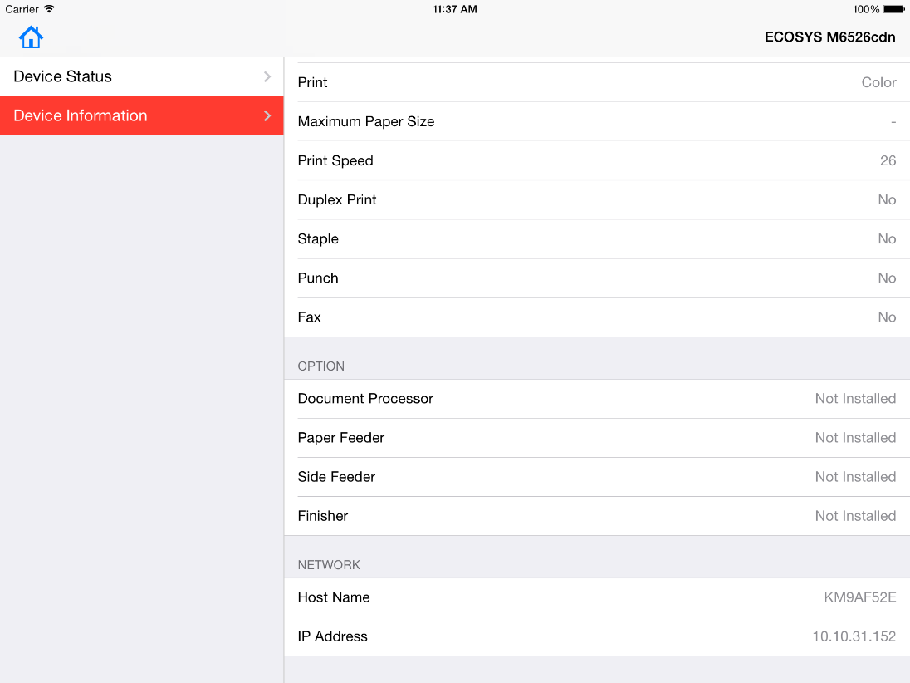
Device information

System Menu

Access system menu features such as User Login, Job Accounting, and feature management.

・Authentication Features

Job Accounting and User Login features help administrators efficiently manage devices and users. For each job, authentication to the device starts when the job is sent and ends when the job is finished.
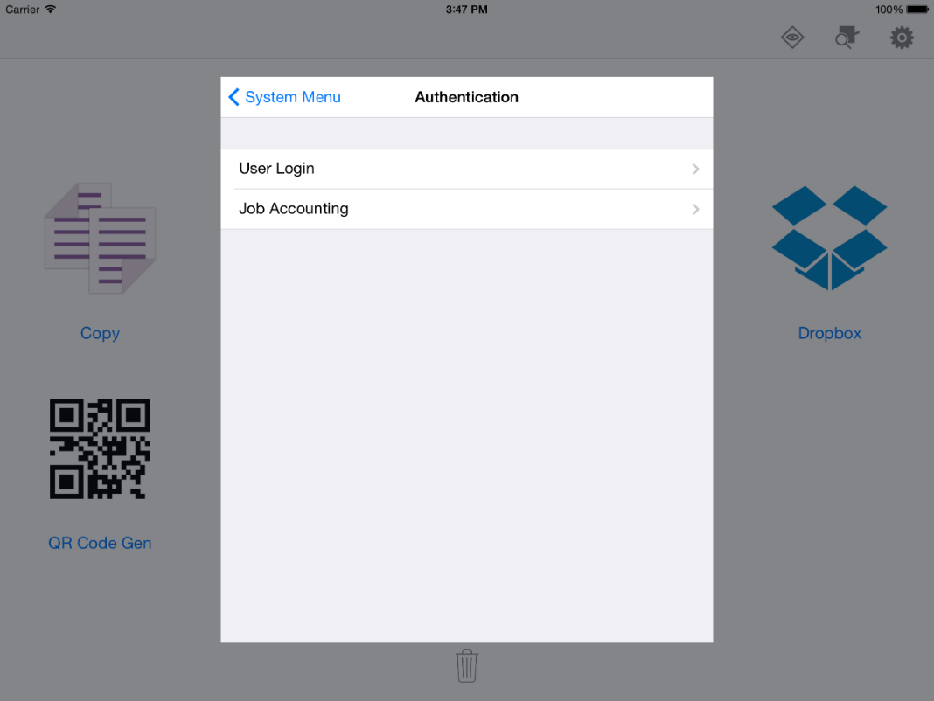
Authentication screen
Job Accounting

The Job Accounting feature, available in System Menu, gives an administrator control of a printing device. With Job accounting, account IDs (identification numbers) can be assigned to users or departments. A specific account ID can be assigned, and then required before printing. Job accounting must be turned on at the device. Custom box files cannot be printed with Job accounting validation.
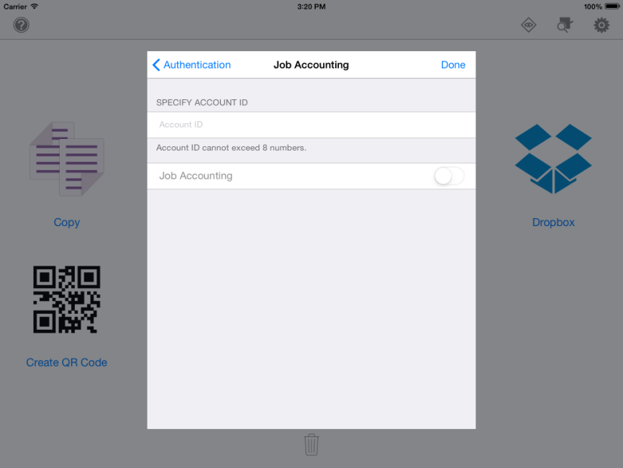
Job accounting screen

User Login

Users are identified by user name and password. The user name can be in the user principal name UPN format: username@domain.com. This feature limits printing privileges to specified users for secure printing and accounting. User login must be enabled on the device.
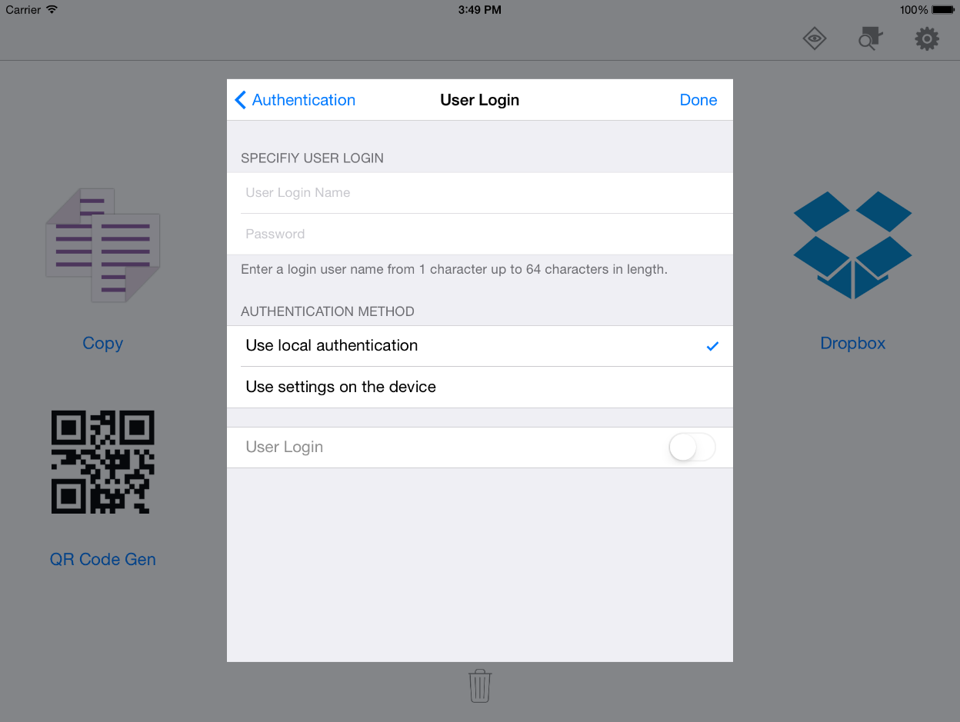
User login screen

Customize your home screen

You can change the order of icons on the home screen. You can also delete the icons of features and workflows that you do not need.

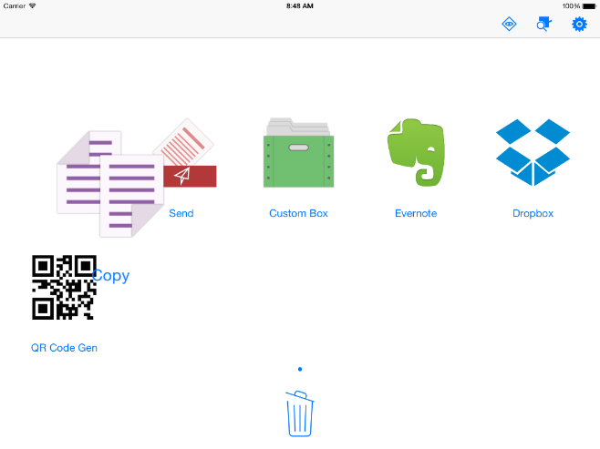
Removing a feature from the home screen

Feature Management

Select the features you want to show on the MyPanel home screen.
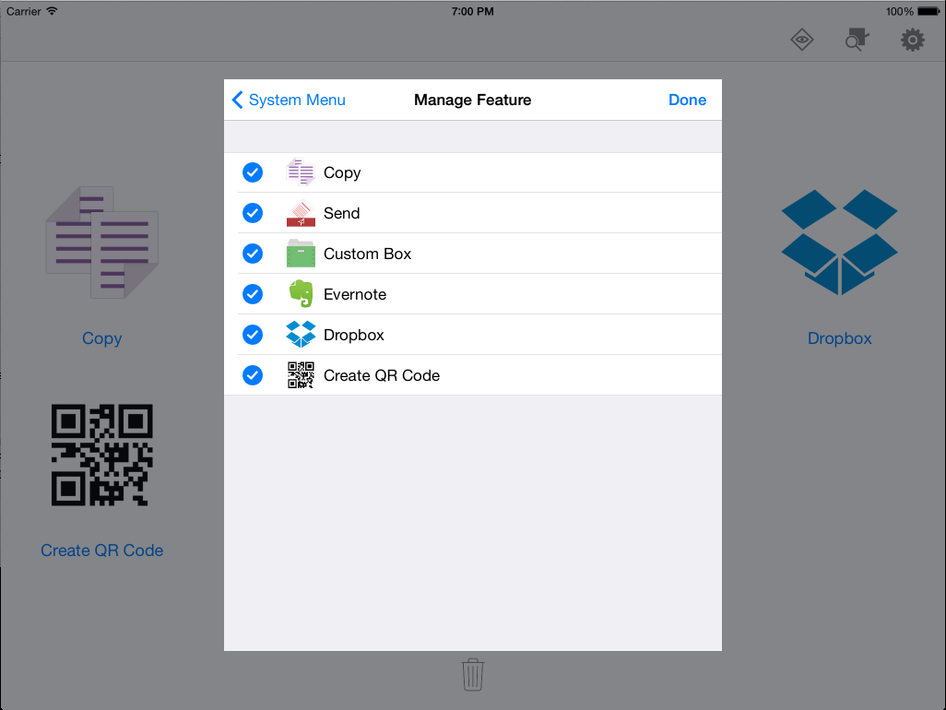
Manage Feature

Application Requirements

Supported File Types

The following table contains all the file formats supported by MyPanel:

File Type | Preview  (iOS) | Print  (iOS) | Preview  (Android) | Print  (Android) | Preview  (Windows Phone) | Print  (Windows Phone)
JPEG | ✔ | ✔ | ✔ | ✔ | ✔ | ✔
PNG | ✔ | ✔ | ✔ | ✔ | ✔ | ✔
TIFF | ✔ | ✔ | ― | ✔ | ✔ | ✔
BMP | ― | ― | ✔ | ✔ | ✔ | ✔
PDF | ✔ | ✔ | ✔ | ✔ | ✔ | ✔
Encrypted PDF | ✔ | ✔ | ✔ | ✔ | ―
TXT | ✔ | ✔ | ✔ | ✔ | ✔ | ✔
XPS |  | ✔ |  | ✔ | ― | ✔
Microsoft Office (Word, Excel, PowerPoint) | ✔ | ✔ | ― | ― | ― | ―
iWork (Keynote, Numbers, Pages) | ✔ | ✔ | ― | ― | ― | ―
RTF | ✔ | ✔ | ― | ― | ― | ―
Evernote notes | ✔ | ✔ | ✔ | ✔ | ― | ―
NOTE: Print options such as orientation, colour mode, and duplex are currently not available for Evernote, Dropbox, or OneDrive. The app uses default settings to print documents from these features.

Supported Languages

MyPanel is available in the following languages:
- English
- German
- French
- Italian
- Spanish
- Portuguese
- Japanese
- Korean
- Chinese – Traditional
- Chinese – Simplified
NOTE: The app automatically displays in the same language as that set in your mobile’s system settings. If your mobile is set to a language other than the supported languages, the app will display in English.

Supported Operating Systems

MyPanel is available for the following devices and mobile operating systems:

- iPad, iPhone, and iPod Touch
iOS 7.0 and later
- Android smartphones and tablets
Android 3.0 and later
- Windows Phone
8.1 and later

Supported Device Models

The following models are supported in version 1.0.

Product Name | Firmware
ECOSYS M6535cidn | From launch
ECOSYS M6035cidn | From launch
ECOSYS M6530cdn | From launch
ECOSYS M6030cdn | From launch
ECOSYS P7040cdn | From launch
ECOSYS P6035cdn | From launch
ECOSYS P6130cdn | From launch
ECOSYS M3540dn * | 2NZ_2000.003.xxx
ECOSYS M3040dn * | 2P0_2000.003.xxx
ECOSYS M2535dn * | 2PL_2000.003.xxx
ECOSYS M2035dn * | 2PK_2000.003.xxx
ECOSYS M2530dn * | 2PL_2000.003.xxx
ECOSYS M2030dn * | 2PK_2000.003.xxx
ECOSYS M6526cdn * | 2PW_2F00.003.xxx
ECOSYS M6026cdn * | 2PV_2F00.003.xxx
* Firmware update is necessary to use MyPanel.

User login and job accounting are not supported for TIFF files (Android).
The first page of the PDF is displayed in the preview (Windows Phone).
User login and job accounting are not supported for TXT files (Windows Phone).
User login and job accounting are not supported for XPS files.
If you use iOS 8.0 or iOS 8.0.2, upgrade your mobile to iOS 8.1 to print .RTF files.
The preview feature for Evernote notes is limited for Android.

